**REPORT**

**LAB 3 : Dicee App**

**Student name: Nguyễn văn hùng**

**Student ID: 21IT614**

**Student email: nvhung2.21it@vku.udn.vn**

# **Introduction**

* Briefly describe the purpose of the lab report.

The objective of this lab is to explore the functionalities of the TextButton and Expanded Widget in Flutter. Additionally, it aims to deepen understanding of two application states: Stageless and Stagefull. Through this exploration, participants will gain insights into how these widgets and application states contribute to building responsive and dynamic user interfaces

* Provide background information on your mobile app.

App Name: Dicee – Flutter

Purpose: The objective of the dice rolling app is to provide users with a digital tool for generating random dice rolls. It serves as a convenient and efficient solution for various gaming, decision-making, or educational purposes where randomized outcomes are required.

# **Objectives**

* State the objectives of the lab.

The objectives of the lab are to familiarize participants with the functionalities of the TextButton and Expanded widgets in Flutter, and to deepen their understanding of two application states: Stageless and Stagefull. Through hands-on exploration and experimentation, participants will gain practical knowledge of how these widgets can be effectively utilized to create dynamic user interfaces, and how different application states can impact the behavior and layout of their Flutter applications.

# **Methodology**

* Describe the methodology used in the lab.

The methodology of the lab involves a combination of theoretical instruction, practical demonstrations, and hands-on exercises. Participants are introduced to TextButton and Expanded widgets through theoretical explanations, followed by demonstrations of their usage. Hands-on exercises allow participants to apply their knowledge in real-world scenarios under the guidance of instructors.Explain how your app was developed.

# **Results**

* Include screenshots of the app.

|  |  |
| --- | --- |
|  |  |

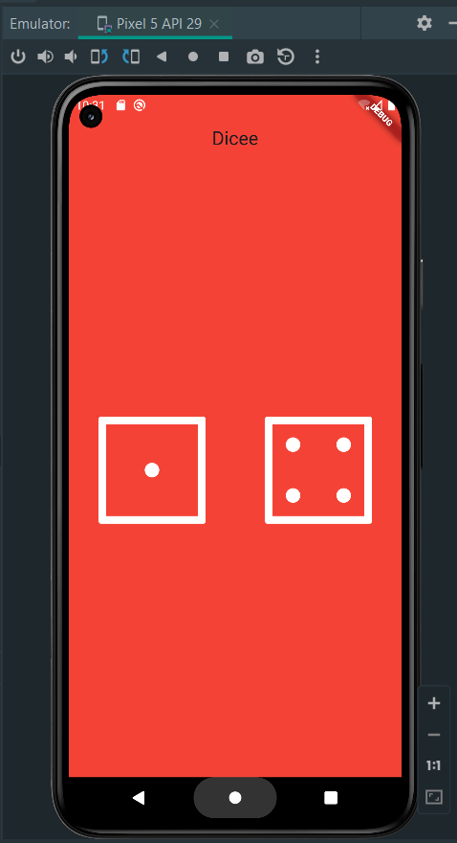

# **Discussion**

* Discuss the results obtained.

The results obtained from the lab demonstrate a comprehensive understanding and practical application of TextButton and Expanded widgets in Flutter development. Participants successfully integrated these widgets into their projects, showcasing dynamic user interfaces with enhanced functionality. Additionally, participants gained insight into the behavior of Stageless and Stagefull application states, enabling them to create more responsive and adaptable Flutter applications. Overall, the lab highlighted the effectiveness of hands-on learning in mastering Flutter widgets and application states

# **Conclusion**

* Summarize the main findings of the lab.

Strong understanding and utilization of the Scaffold widget for app layout.

Effective management of dependencies and assets using the Pubspec file.

High-quality documentation providing clear instructions and explanations.

* Provide recommendations for future work.

Explore advanced Flutter topics like state management and animation.

Assign real-world projects for practical application of skills.

Encourage collaborative group projects for teamwork experience.

Provide continuous learning resources and encourage self-study.